**Steps for Preparing OQS Report**

**To check the log in Mule Server:**-

1. First of all you have to open mule server **xlpsvc13** and then you have to check the log in OQS Version **2_9, 1_25, 1_24** whether there is any **error** or not and also **Passport data** received or not.(log path root/opt/oqs/logs/**oqs version(1_24,1_25,2_9)**).

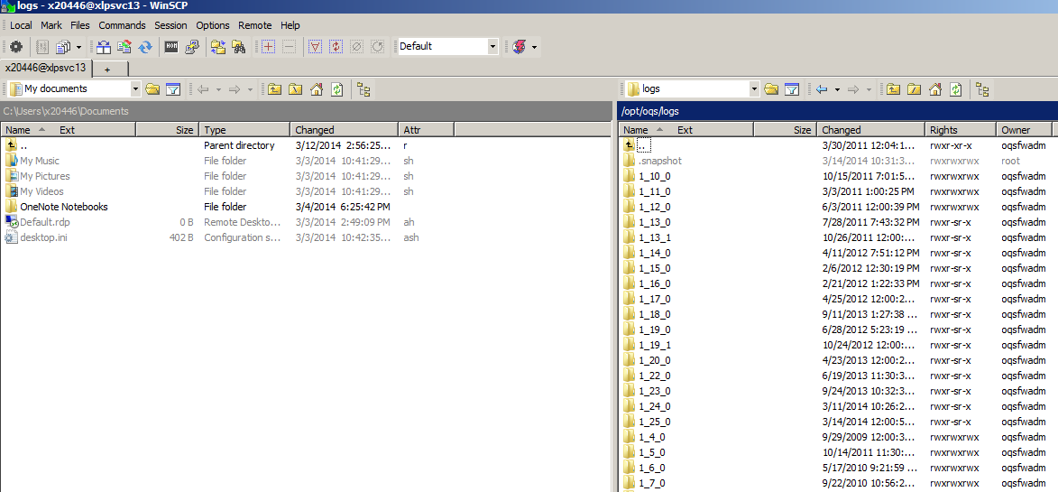

1. You have to follow the same step to open mule server **xlpsvc14** and to check the log there.
2. In case of Passport Data receive, Please make it highlight if found that Passport Data received in same server continuously for 3 day (Continuously 2 day is ok but if It exceed then there is an issue).

**To check memory consumption:-**

1. First of all you have to open putty for the particular server( **whether it is xlpsvc13 or xlpsvc14**)
2. Then use command **top –p 12210** to check

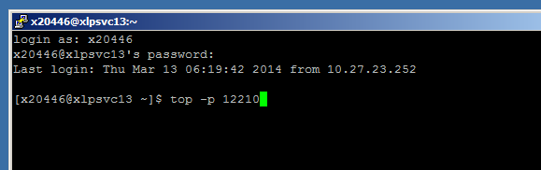

It will shows you the result where **%MEM** is the total memory consumption by that application on that particular day

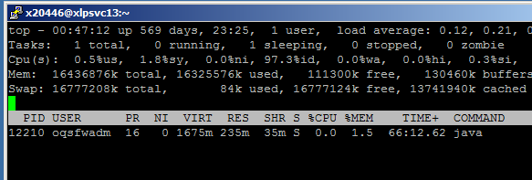

**Note**: Here 12210 is the application Id. If you found that after executing your command it not showing any result then you have to check whether the application id is changed or not (changing of application ID depends on restarting of service i.e. If any service is restarted then Id of that application get automatically changed). If changed then you have to use that application Id in place of old one. To check that you have to follow below step->

1. Go to <https://swaservices.swacorp.com/SWAServicesConsole/>
2. Then use your credential to login (if you have access) and select the environment from the dropdown whether it is **xlpsvc13** or **xlpsvc14** and make sure the upper tab is selected to **PROD.**

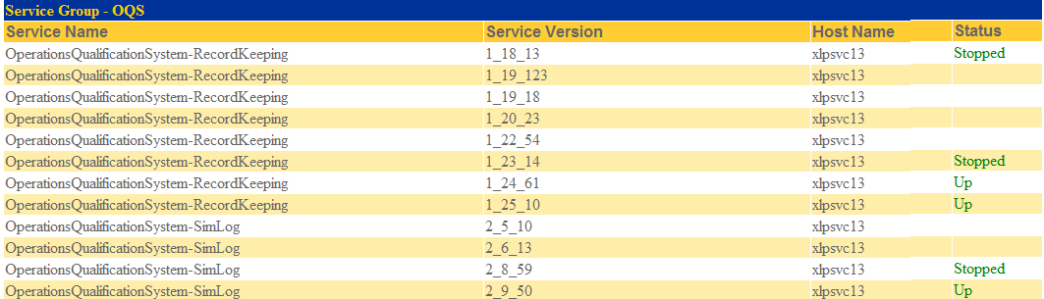

1. Then make a click on that particular Service Name you are searching for. It will shows you the **AppPID** i.e. application ID.

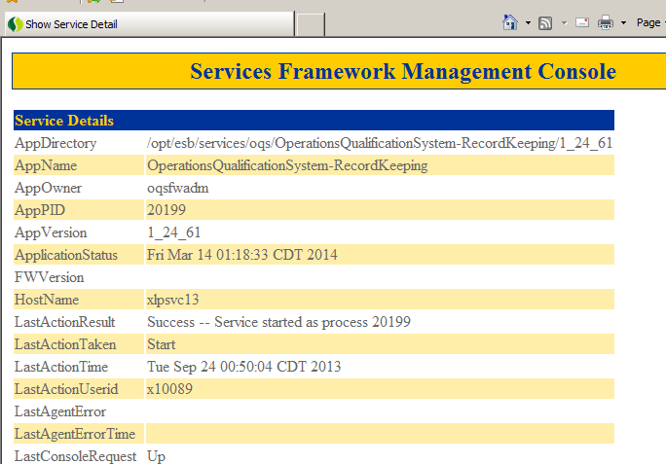

**For Batch Job results:-**

1. Open PLSQL Developer

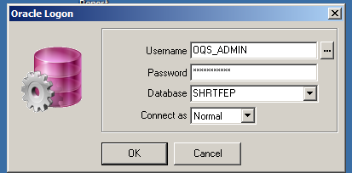

1. Then open SQL window from **File** Menu(File->New->SQL Window) and paste the below query there and make a click on execute.

**Query:**

**select**

**j.job_id,**

**decode(j.job_definition_id, 10, 'SimLog',**

**11, 'SimLog',**

**'OQS') as "Application",**

**jd.job_description,**

**js.job_status_description,**

**j.status_desc_text,**

**j.start_run_date,**

**j.end_run_date,**

**to_timestamp (j.end_run_date,'yyyy-mm-dd HH24:MI:SS') - TO_TIMESTAMP (j.start_run_date,'yyyy-mm-dd HH24:MI:SS') as "Elapsed Time",**

**j.submitted_by_id,**

**j.last_update_date**

**from job j, job_status_type js, job_definition jd**

**where j.job_status_type_id = js.job_status_type_id**

**and j.job_definition_id = jd.job_definition_id**

**and**

**(**

**(j.start_run_date = (select max(start_run_date) from job where job_definition_id = 1) and j.job_definition_id = 1)**

**or**

**(j.start_run_date = (select max(start_run_date) from job where job_definition_id = 2) and j.job_definition_id = 2)**

**or**

**(j.start_run_date = (select max(start_run_date) from job where job_definition_id = 3) and j.job_definition_id = 3)**

**or**

**(j.start_run_date = (select max(start_run_date) from job where job_definition_id = 10) and j.job_definition_id = 10)**

**or**

**(j.start_run_date = (select max(start_run_date) from job where job_definition_id = 11) and j.job_definition_id = 11)**

**or**

**(j.start_run_date = (select max(start_run_date) from job where job_definition_id = 50) and j.job_definition_id = 50)**

**or**

**(j.start_run_date = (select max(start_run_date) from job where job_definition_id = 100) and j.job_definition_id = 100)**

**);**

1. It will show some result. Make a copy of that result in a .xls file.